VISTA Seminar

Seminar 34

March 30, 2022

10:00 am – 11:30 am EDT / 2:00 – 3:30 pm GMT /3:00 – 4:30 BST / 4:00 pm – 5:30 pm Paris

TOC:

1. Presenter 1: Prof. Haibo Ma, Nanjing University, China……………...... page 2
2. Presenter 2: Dr. Johann Mattiat, University of Zurich, Switzerland …..... page 3
3. How to connect………………………………………………………..…. page 4

**Model Construction and TD-DMRG Simulation for Exciton Dynamics in Molecular Aggregated Systems**

Haibo Ma

*School of Chemistry and Chemical Engineering, Nanjing University, Nanjing 210023, China Email:* [*haibo@nju.edu.cn*](mailto:haibo@nju.edu.cn)

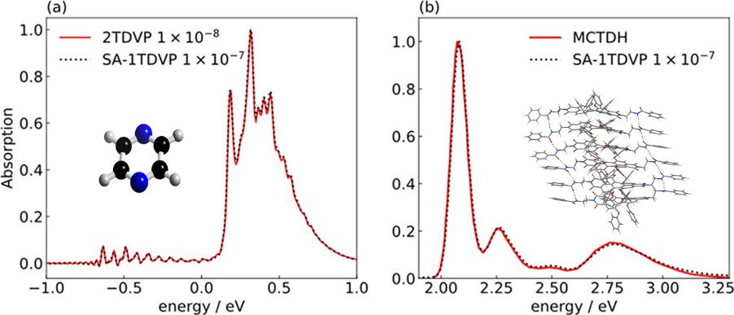

Excitonic model Hamiltonians are widely used in the theoretical simulation of excited state dynamics and spectroscopy in large photoactive systems, such as molecular aggregates in organic optoelectronic materials and biological light-harvesting systems. However, the choices of model basis and parameter values are heavily dependent on experimental fitting or empirical setting, hindering their routine applications to new chemical systems. Moreover, their real-time quantum dynamics simulations are also highly challenging for excitonic systems with strong exciton−vibration/phonon couplings due to the exponentially growing computational costs with the increasing system size. In this talk, I will introduce our recent developments of an automatic scheme for the accurate construction of the bases for excitonic models,1 and an approximate approach for the efficient evaluation of exciton-phonon couplings.2 I will also introduce our recent efforts on applying time-dependent density matrix renormalization group (TD-DMRG) method for real-time quantum dynamics simulations of realistic excitonic systems3,4 with a large number of vibrational degrees of freedom, and the development of a new stochastic adaptive single-site TD-DMRG algorithm,5 which integrates the traditional advantages of both the high efficiency of the single-site variant and the high accuracy of the two-site variant.

**References**

1. K. Wang, Z. Xie, Z. Luo, H. Ma, *J. Phys. Chem. Lett.* **2022**, 13, 462.
2. X. Xie, A. Santana-Bonilla, W. Fang, C. Liu, A. Troisi, H. Ma, *J. Chem. Theory Comput.* **2019**, 15, 3721.
3. Y. Yao, K. Sun, Z. Luo, H. Ma, *J. Phys. Chem. Lett.* **2018**, 9, 413.
4. X. Xie, Y. Liu, Y. Yao, U. Schollwöck, C. Liu, H. Ma, *J. Chem. Phys.* **2019**, 151, 224101.
5. Y. Xu, Z. Xie, X. Xie, U. Schollwöck, H. Ma, *JACS Au* **2022**, 2, 335.

**Optical and vibrational spectroscopy of (chiral) systems with RT-TDDFT: Gauge dependence and linear response**

Johann Mattiat

*University of Switzerland, Zurich, Switzerland; Email:* [*johann.mattiat@gmail.com*](mailto:johann.mattiat@gmail.com)

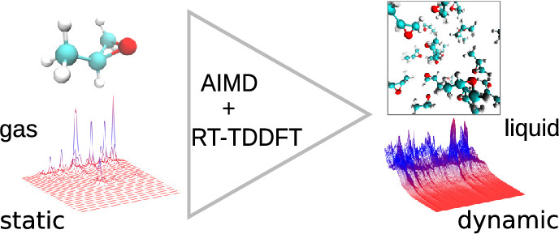 

Real-time time-dependent density functional theory (RT-TDDFT) has become a widely used tool for the simulation of optical (linear) response. Apart from its favorable scaling and its capacity to resolve the entire energy domain linear response functions in one go, RT-TDDFT provides a unique framework to address the gauge dependence of practical calculations.

In this contribution recent results for UV-VIS absorption[1], electric circular dichroism[2], Raman[1] and Raman optical activity[3] are presented in unified linear response formalism, including approaches to Raman spectroscopy for the gas and liquid phase[4]. Specifically the reference point and gauge origin dependence of magnetic and quadrupolar response as well as the inherent gauge dependence stemming from the use of finite basis sets and non-local potentials are discussed.

**References**

[1] J. Mattiat, S. Luber, J. Chem. Phys., 149, 174108, (2018)

[2] J. Mattiat, S. Luber, Chem. Phys, 527, 110464, (2019)

[3] J. Mattiat, S. Luber, J. Chem. Phys., 151, 234110, (2019)

[4] J. Mattiat, S. Luber, J. Chem. Theory Comput., 17, 1, 344–356, (2021)

**How to connect**

Alexey Akimov is inviting you to a scheduled Zoom meeting.

Topic: VISTA, Seminar 34

Time: Mar 30, 2022 10:00 AM Eastern Time (US and Canada)

Join Zoom Meeting

https://buffalo.zoom.us/j/99705325470?pwd=QzBVSm9IUExEQzVvMWkwNzdYMWtPZz09

Meeting ID: 997 0532 5470

Passcode: 998118

One tap mobile

+16465588656,,99705325470#,,,,*998118# US (New York)

+13017158592,,99705325470#,,,,*998118# US (Washington DC)

Dial by your location

+1 646 558 8656 US (New York)

+1 301 715 8592 US (Washington DC)

+1 312 626 6799 US (Chicago)

+1 253 215 8782 US (Tacoma)

+1 346 248 7799 US (Houston)

+1 669 900 9128 US (San Jose)

Meeting ID: 997 0532 5470

Passcode: 998118

Find your local number: https://buffalo.zoom.us/u/aeiyllT08Q

Join by SIP

99705325470@zoomcrc.com

Join by H.323

162.255.37.11 (US West)

162.255.36.11 (US East)

115.114.131.7 (India Mumbai)

115.114.115.7 (India Hyderabad)

213.19.144.110 (Amsterdam Netherlands)

213.244.140.110 (Germany)

103.122.166.55 (Australia Sydney)

103.122.167.55 (Australia Melbourne)

149.137.40.110 (Singapore)

64.211.144.160 (Brazil)

69.174.57.160 (Canada Toronto)

65.39.152.160 (Canada Vancouver)

207.226.132.110 (Japan Tokyo)

149.137.24.110 (Japan Osaka)

Meeting ID: 997 0532 5470

Passcode: 998118